**Final Prototype Test Report**

To: Professor Pisano

From: Aidan McCall, Jonas Escobar

Team: Team 30: Smart Grid

Date: 4/8/22

Subject: Final Prototype Test Plan

1. **Materials Required**

Hardware

* Smart Grid Test Facility
* PC Computer
* PicoScope
* NI myDAQ
* Banana cables/BNC-Alligator probes
* Electrical outlet

Software

* MATLAB
* MATLAB Signal Processing packages
* Proper DAQ driver softwares
  + NI DAQ mx Elvis/driver software
  + MATLAB Data Acquisition Toolbox
  + MATLAB Data Acquisition Toolbox Support Package for NI-DAQmx Devices
* Final GUI
* Picoscope App
* PicoScope analysis MATLAB script

**2.0 Setup**

2.1 Preparing the model for operation

1. Plug the power strip into the wall. This powers the variac (which starts in the OFF position), the +/- 15 V power supply that powers the sensor boards, the 24 VDC power supply that powers the generators.
2. Make sure that all transmission lines have the top three switches ON and the bottom three switches OFF.
3. Before connecting the model, plug in the 5V 1A power adapter that powers the synchronization circuits. Once plugged in, the LEDs on the MSP30's should light up.
4. Wait a few seconds to let the MSP30's settle, and then turn on the main switch on top, labeled 24V, to bring power to the rest of the model.
5. The variac/reference generator is turned on after.

2.2 Setting up the PicoScope

1. Plug the PicoScope into a computer.
2. Attach the probes to point 1 and point 3 (comparing Generator A to the point it is being added to the grid), according to Figure 1.

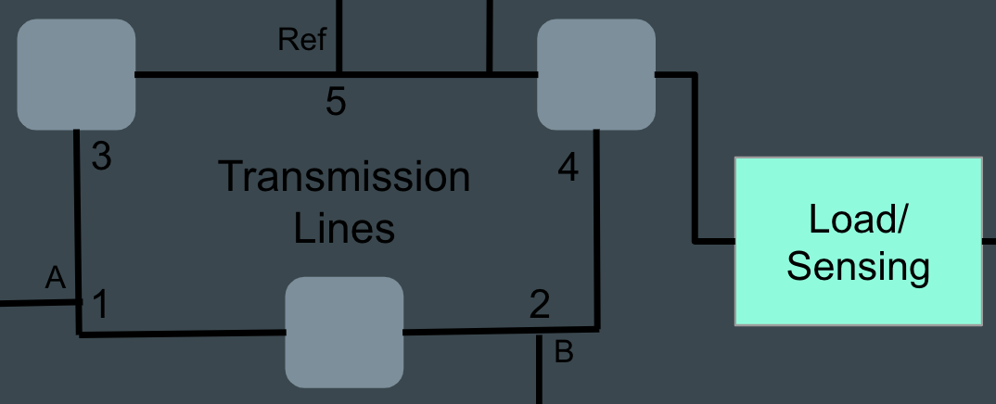

*Figure 1: Basic schematic of the grid*

1. Pulling up the PicoScope 6 application should bring up a live feed with the 60 Hz, 24Vpp wave being visible on the computer, which is coming from the reference variac.

2.3 Activating the generators and synchronizing

1. To turn on a generator, we reset the microcontroller by pressing the button labeled by an arrow for the MSP430 corresponding to that generator. When the button for A is pressed, the generator will begin its rotation and it should now be visible on the PicoScope (from point 1). The peak-to-peak voltage should be about the same as the reference.
2. Next, flip the slide switch on the synchronization circuit for A to the green/on position, which will give additional feedback via the LED. The LED will flicker on and off due to the phase differences between the reference generator voltage and the signal produced by generator A; the two signals are in phase when the LED is dim, and out of phase when it is lit up (i.e. out of phase means there will be a voltage difference across the diode causing it to be lit).
3. The toggle switch (with on/off labels) should be closed (switched to on) at a moment when the two waves are in phase.
4. Closing this will short circuit the two nodes we’re measuring on the PicoScope, so the probe at point 1 should be moved to point 5 to compare generator A to the reference. This way we can check that the peak-to-peak voltage is remaining constant, and if it’s not then the main 24V switch should be switched off, along with the variac, to reset the model and start over. The frequency of generator A should also stabilize to the reference 60Hz, but there may be some instability.
5. These steps will be repeated for generator B, with the PicoScope initially measuring at points 2 and 4 in Figure 1 (moving point 2 to point 5 in step 4). After closing the toggle switch, if voltage amplitudes are remaining constant, then the grid is running properly.

**3.0 Testing Procedure—Measurements through Software**

3.1 Current and Voltage Waveforms

After setup was complete, the PicoScope and DAQ were connected to the computer for collecting data. To view the sources for the load under test, we placed the two oscilloscope channels on either side of the transmission line PCB that the load was added to. Before the load is added, the grid signal is a clean sine wave, but Figure 2b shows how the addition of the load changes the quality of that sine wave. While both generators are on, this wave fluctuates in both amplitude and frequency. Additionally, the theoretical phase angle is different from what we calculate from the measurement (Figure 2a shows the measurement result). However, when the generators are removed from the grid, and only the reference generator is powering the load (Figure 3), the measured phase matches the theoretical phase within 5°. The source signal (3b) also has less fluctuation, but the sine wave is highly distorted by harmonics.

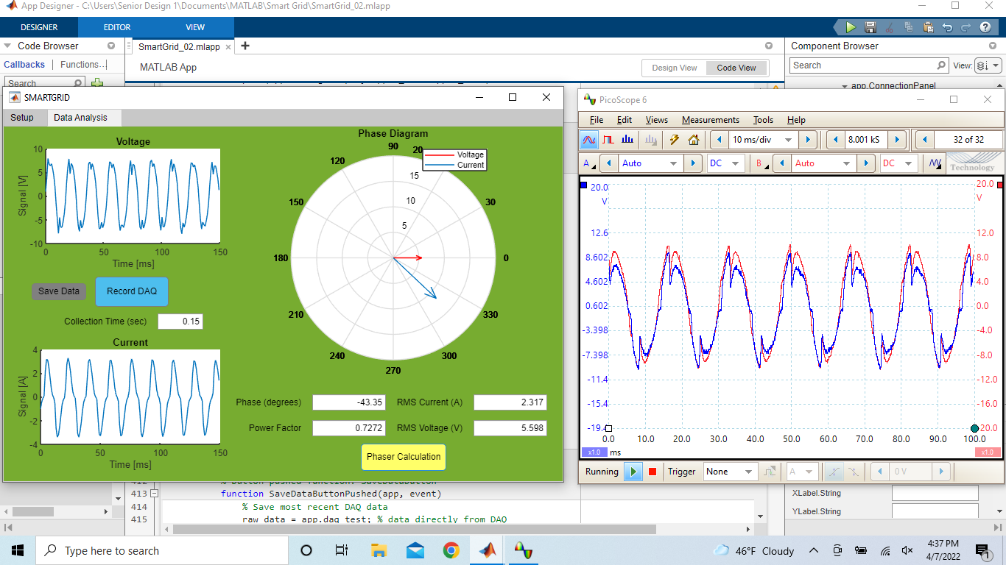

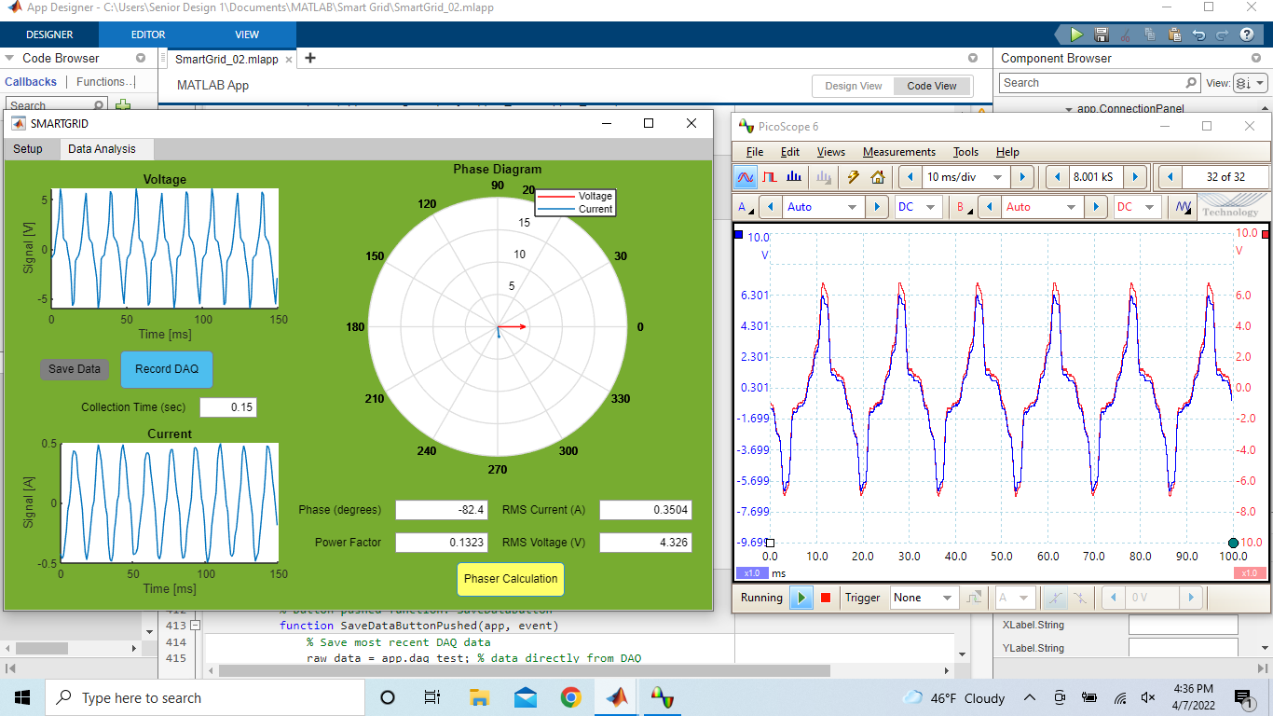

*Figure 2 & 3: Current and voltage signals, phase diagram, and calculated values measured in the inductive load circuit are shown in the left GUI window (2a, 3a). The right window (2b, 3b) shows the oscilloscope signal measured at points 1 and 2 in Figure 1; in Figure 3, generators A and B were removed from the grid.*

3.2 Phase Angle Measurements Taken

Two different angles were measured for a certain switch configuration. One angle was measured when Generator A and B were connected to the grid. The second angle was measured when only the reference generator was generated. Table 1 shows the results of the testing.

*Table 1*

| Load (H) | Calculated Phase (degrees) | Measured Phase (degrees) with only Reference Generator | Measured Phase (degrees) with Gen A, B, and Reference |
| --- | --- | --- | --- |
| 0.1901 | -81.852064 | -83.04 | -47.89 |
| 0.144 | -79.450134 | -75.65 | -33.76 |
| 0.1301 | -78.425619 | -77.71 | -36.68 |
| 0.1028 | -75.713664 | -71.22 | -29.21 |
| 0.0821 | -72.659963 | -74.15 | -33.13 |

**4.0 Success Criteria**

Success for this prototype testing was measured by the following criteria:

1. Successfully operate the grid entirely on-cart.
2. Successfully start the grid with both generators synchronized and connected to the grid
   1. Synchronization means the 2 generators are added to the grid and no major changes in frequency and Vpp are observed. Note: all three generators will not necessarily be in phase.
3. Successfully connect the PicoScope to the grid, and observe the live feed, using it to synchronize generator B.
4. Successfully connect and collect data from the DAQ, understand what the data is showing about the loads inserted to the grid.
5. Successfully plot voltage, current, and phase data for an inductive load.
   1. Plots should be sinusoidal. Current should lag voltage.
6. When the reference generator is the only power supply, the measured angles should be within 7°.

**5.0 Conclusions**

Based on these measurements, this prototype test was a success under the measurable criteria stated above.

1. The grid was successfully operated entirely on-cart.
2. The generators were successfully synchronized and connected to the grid.
3. The PicoScope was successfully used to synchronize while observing the live feed.
4. We successfully connected to the DAQ and collected data.
5. We successfully plotted voltage, current, and phase data for an inductive load.
   1. The phasor diagram was accurate and visually useful for potential use in a classroom setting.
   2. The voltage and current data appeared to have harmonics as seen in Figure 3. Based on the data and testing different points in the grid, it appears that the issue is likely with the sensor boards or the inductive load itself. Because the inductive loads are hand-wound and close together, this could be causing issues and distorting the signal. To combat this, we are going to try to test the sensor board with different loads to see if that is the issue. If it is not, we will make new inductive loads with a breadboard to try to get a more clear signal.
6. Based on Table 1, the measured data was all within 7° of the calculated data when only the reference generator was connected. Ideally, when the issue with the harmonics is fixed, the measured data should always be correct regardless of which generators are connected. However, because we measured the correct data with the reference generator, it can still be used as a helpful tool to use in class.

Before ECE Day, we would like to clean up some of the data measurements. Nevertheless, our GUI is working as expected.